NexAround
Complete Platform Architecture & System Specification
AI-Powered, Location-Aware Smart Tourism Platform
Prepared as a Master Reference Document
Covers: System Architecture · Mobile & Backend Design · Data Layer · Operational Workflows · Security · CI/CD · Deployment

Table of Contents
- 1. Document Overview & System Purpose
- 2. High-Level Architectural Flow
- 3. Sub-System Specifications & Module Breakdown
- 4. Mobile Client Architecture (nexaround_app)
- 5. Backend Service Architecture (nexaround_backend)
- 6. Data Architecture & Storage Strategy
- 7. End-to-End Operational Workflows
- 8. Security, Compliance & System Governance
- 9. Infrastructure & Deployment Topology
- 10. Summary of Technical Advantages

1. Document Overview & System Purpose
The NexAround Platform is an AI-powered, location-aware travel planning and destination discovery system designed to provide users with personalized travel experiences. The platform combines Artificial Intelligence (AI), Geographic Information Systems (GIS), Augmented Reality (AR), and modern web technologies to help users plan trips, discover nearby attractions, explore museums, and manage travel budgets through a single mobile application.
The system uses a layered architecture consisting of the presentation layer, gateway layer, application layer, database layer, caching layer, and external service integrations. This separation of concerns improves scalability, maintainability, and overall system performance while allowing each component to operate independently.
The backend is developed using FastAPI, providing high-performance asynchronous REST APIs. PostgreSQL with PostGIS is used to store and process geographical data efficiently, while Redis improves application performance by caching frequently accessed data. The platform also integrates external AI, mapping, and geocoding services to provide intelligent travel recommendations and real-time location information.
The entire system is containerized using Docker Compose behind an Nginx reverse proxy, ensuring consistent deployment across development and production environments. Security is maintained through HTTPS communication, JWT-based authentication, role-based access control, and strict request validation via Pydantic schemas.

1.1 Objectives of the System
- Generate personalized AI-powered travel itineraries.
- Provide fast, location-based attraction discovery using spatial data.
- Support AR-based landmark identification and museum exploration.
- Help users manage travel budgets and expenses across currencies.
- Enable users to share travel stories, journals, and reviews.
- Ensure secure, scalable, and high-performance system operation.

1.2 Scope of the System
The NexAround platform allows users to register, manage travel preferences, discover nearby attractions, generate AI-based itineraries, explore world-class museums, explore using AR, monitor travel expenses, and share travel experiences. Administrators can manage users, attractions, museums, categories, and system content through a web-based administration portal. The modular architecture also allows future integration of additional services such as payment gateways and transportation providers.

2. High-Level Architectural Flow
NexAround follows a client-server architecture. To prevent resource abuse and secure third-party API keys, all client devices communicate exclusively with a central backend server, which in turn queries external APIs (Google Gemini AI, Google Maps/Places, Mapbox, Geoapify) securely and caches expensive lookups.

2.1 System Layers
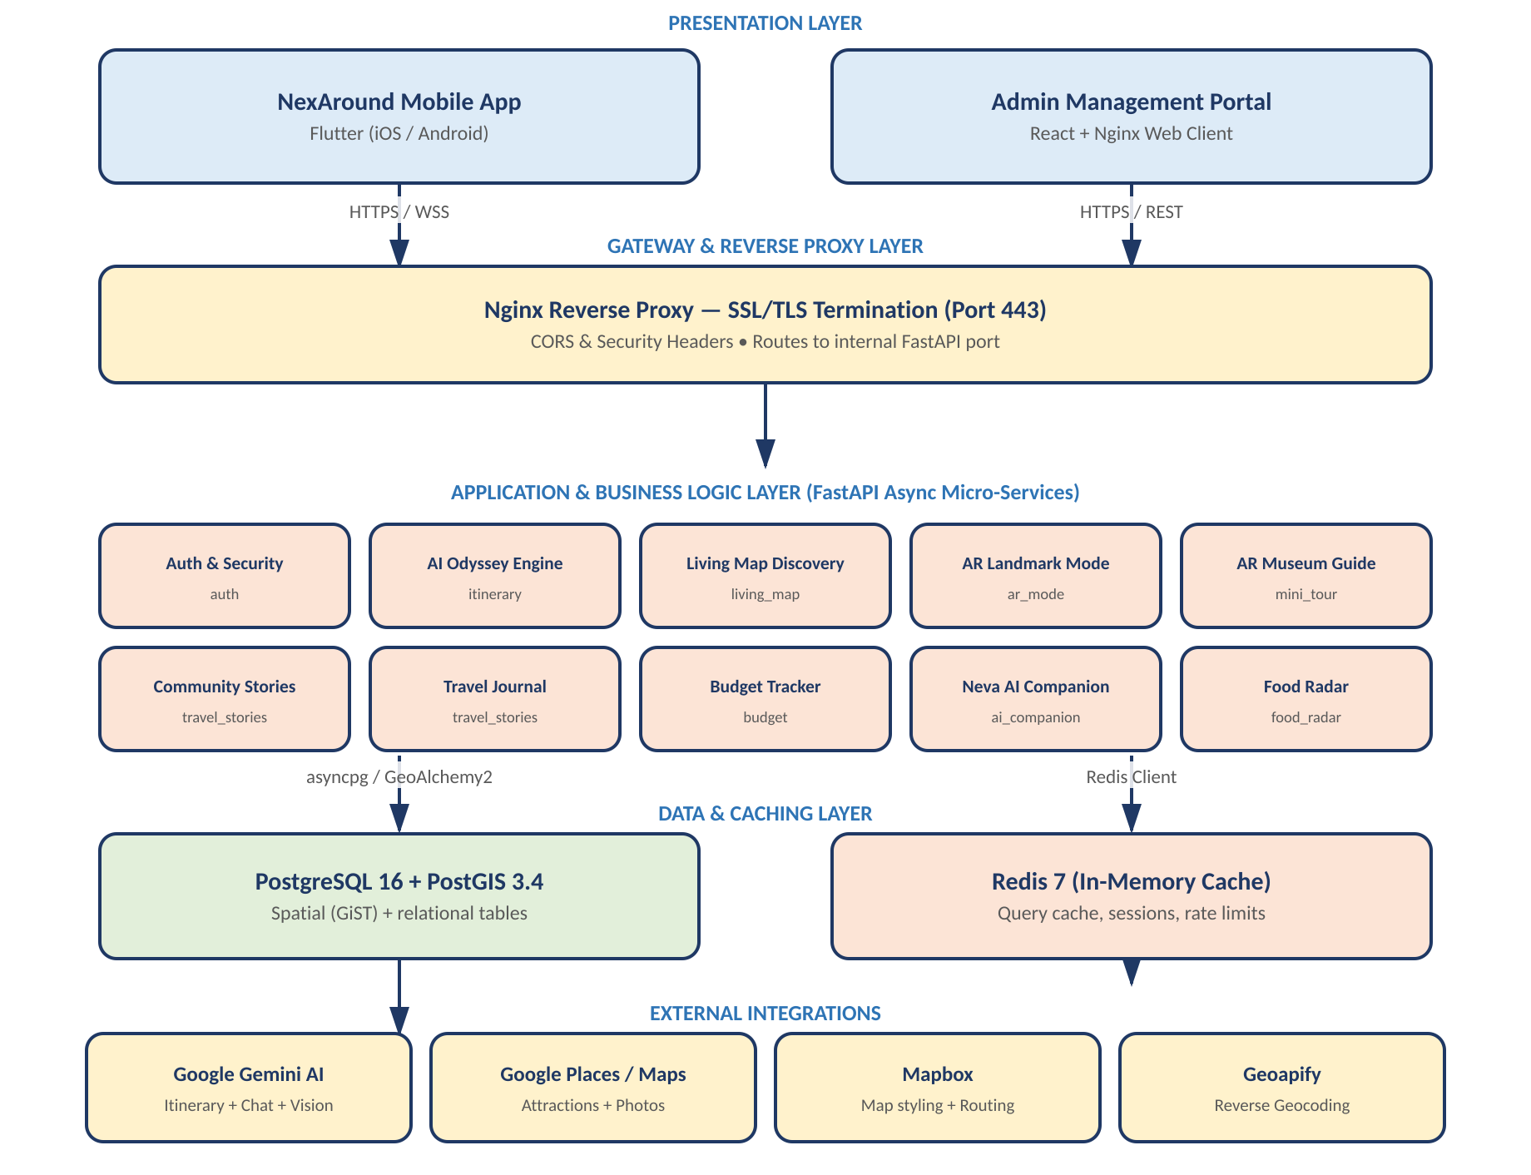
Figure 2.1 - Layered system architecture, from client apps down through the gateway, application services, data layer, and external integrations.

2.2 Component Handshake
The Flutter mobile app and the React/Nginx admin dashboard both communicate with the FastAPI backend exclusively over HTTPS REST. The backend is the sole component authorized to reach PostgreSQL/PostGIS, Redis, and all third-party integrations (Google Places & Photos API, Mapbox Routing API, and Google Gemini AI), ensuring no credentials or direct database access are ever exposed to client devices.

3. Sub-System Specifications & Module Breakdown

3.1 Presentation & Client Interface Layer
The Presentation Layer is the user-facing component of the platform. It consists of the mobile application and the web-based administrative portal, both of which communicate with the backend through secure REST APIs over HTTPS. This layer collects user input, displays travel information, and provides an intuitive interface for interacting with the system.
The mobile application supports user authentication, attraction discovery, AI itinerary generation, AR exploration, museum exploration, budget tracking, and travel story sharing. The administrative portal enables platform administrators to manage users, attractions, museums, categories, reviews, and other system content through a centralized dashboard.

3.2 Gateway & Network Proxy Layer
The Gateway Layer is implemented using Nginx, which acts as the single entry point for all incoming client requests. It handles HTTPS communication, SSL/TLS certificate management, request routing, and security headers before forwarding requests to the FastAPI backend on its internal port. Separating the gateway from the application server improves security, simplifies request management, and enables future scalability through load balancing.

3.3 Core Application Services (FastAPI Micro-Architecture)
The Core Application Layer contains the platform's primary business logic, implemented with FastAPI for asynchronous, high-performance REST APIs. The backend is organized into independent service modules so each component performs a specific business function while the overall system remains modular and maintainable.
1. Authentication & Identity Service - Manages registration, login, password security (bcrypt hashing), and session management. Uses JWT-based authentication and role-based access control (RBAC) so users only access resources permitted by their assigned role.
2. AI Odyssey Itinerary Engine - Generates customized multi-day trip plans based on budget, mood, location, and group size, using asynchronous background workers so complex AI generation never blocks the client. Handles flight/hotel alignment and attraction swapping.
3. Spatial & Proximity Discovery Service - Executes high-performance spatial queries for real-time distance and proximity, filtering attractions by category, operating hours, popularity, and bounding box.
4. AR & Museum Guide Sub-System - Delivers indoor/outdoor coordinates for AR camera overlays and serves museum masterpiece metadata, audio guides, high-resolution assets, and indoor floor maps.
5. Community, Social & Content Hub - Manages user-generated travel feeds, story posting, photo media links, likes, and comment threads, and calculates ratings/sentiment for destinations.
6. Budget & Expense Engine - Helps users monitor travel expenses by comparing estimated versus actual costs across transportation, accommodation, attractions, and other categories, with live currency conversion.
7. System & Notification Hub - Coordinates asynchronous background workers, push notifications, and system-wide settings.

4. Mobile Client Architecture (nexaround_app)
The mobile client is built using Flutter (Dart) and follows Clean Architecture principles combined with the BLoC (Business Logic Component) state management pattern. Each app feature - e.g. living_map, auth, attractions, budget - is split into three independent layers:

4.1 Layered Module Structure
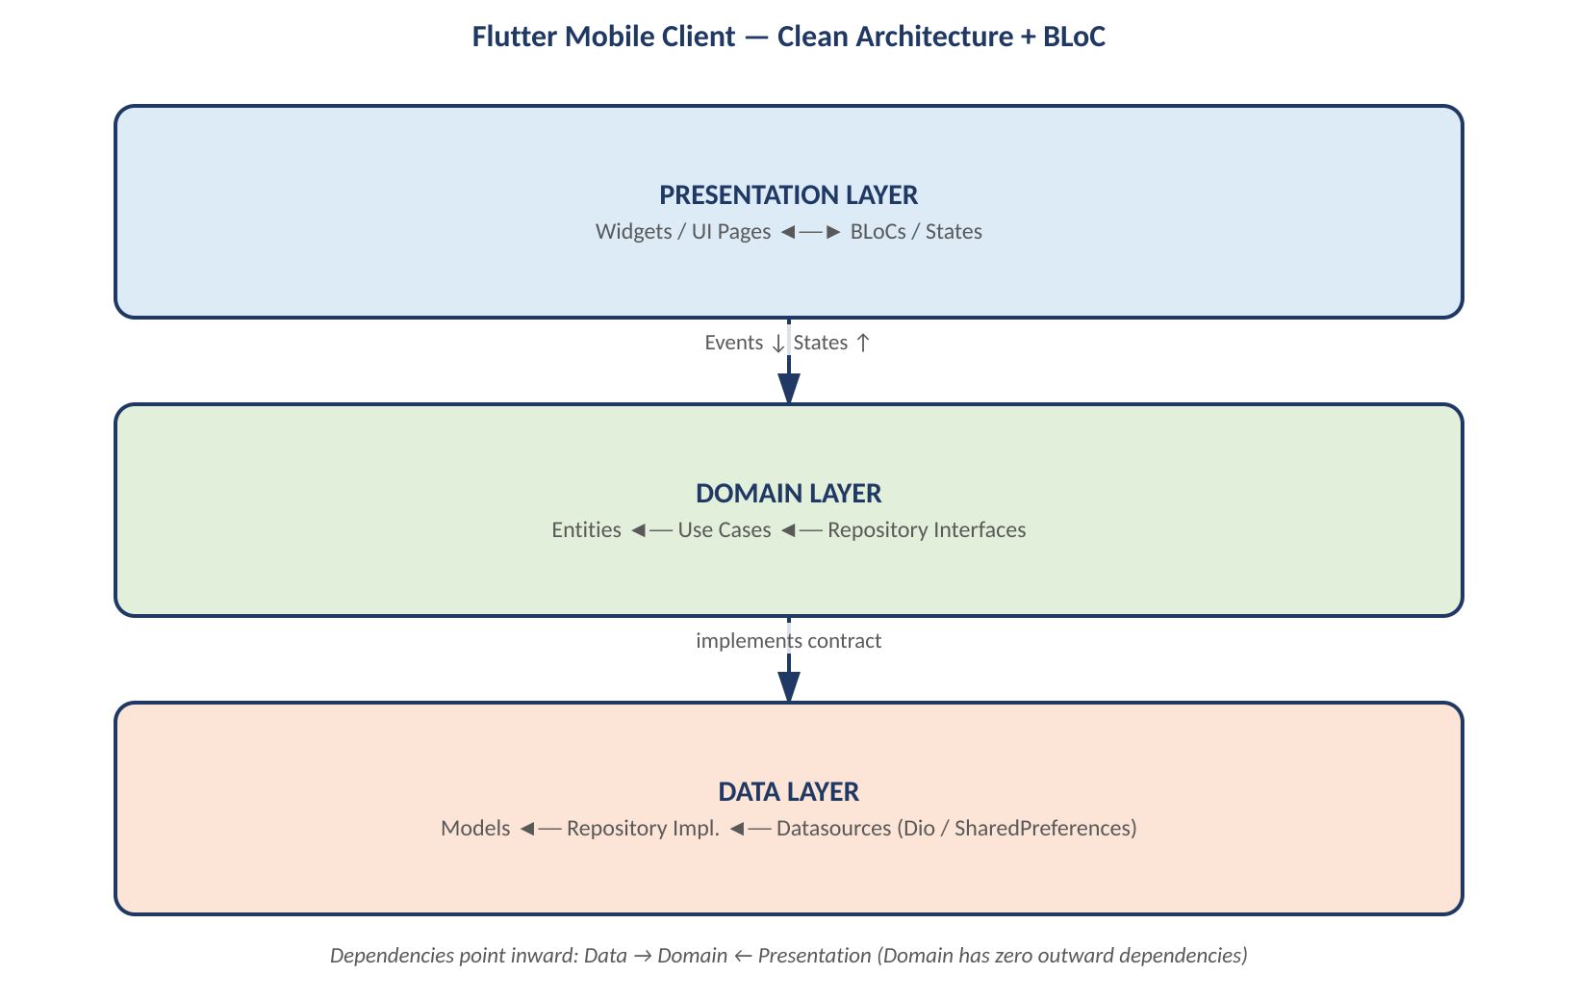
Figure 4.1 - Clean Architecture layering used within every mobile feature module.

4.2 Dependency Stack
- State Management: flutter_bloc
- Navigation / Routing: go_router
- Network Client: dio - with global retry, SSL pinning, and API interceptors
- Dependency Injection: get_it & injectable

5. Backend Service Architecture (nexaround_backend)
The backend is built with FastAPI (Python) and acts as an API gateway, secure key proxy, database coordinator, and geospatial query engine.

5.1 Code Organization
- app/api/ - API endpoint routers grouped under /v1 (auth.py, places.py, proxy.py, etc.)
- app/services/ - Core logic for Google Places geocoding, Gemini AI formatting, map indexing, and currency conversion.
- app/models/ - SQLAlchemy database table definitions mapping Python objects to PostgreSQL.
- app/schemas/ - Pydantic validation schemas for incoming payloads and outgoing serialization.
- app/core/ - Configuration, async database pooling (async_session), security headers, and settings.

5.2 Technology Stack
- Framework: FastAPI & Uvicorn (asynchronous ASGI server).
- Database Interface: SQLAlchemy with async support (asyncpg) and GeoAlchemy2 for PostGIS coordinate operations.
- Caching: Redis - manages coordinate-based grids and resolved maps in memory with custom TTL expirations.
- AI Integration: Official Google GenAI SDK (gemini-2.5-flash and gemini-1.5-pro/flash as fallback models).

6. Data Architecture & Storage Strategy
The platform uses a combination of PostgreSQL, PostGIS, and Redis to provide reliable data storage, efficient spatial processing, and high application performance. PostgreSQL stores all relational data, PostGIS extends the database with geographic capabilities, and Redis improves response times by caching frequently accessed information.

6.1 Primary Database - PostgreSQL 16 with PostGIS 3.4
- Spatial Indexing (GiST): enables sub-second proximity searches across millions of coordinate points using ST_DWithin and ST_Distance.
- users & user_profiles - account metadata, security roles, and travel preferences.
- itineraries & itinerary_items - structured schedules, budgets, flight, and hotel data.
- attractions & categories - geolocated points of interest, photos, and operating hours.
- museums & museum_masterpieces - spatial indoor markers, art details, and exhibit media.
- travel_stories, likes, comments - user interaction feeds and social engagement records.

6.2 In-Memory Performance Layer - Redis 7
- Query Caching: caches frequent geographical searches and static categories to reduce database load.
- Task Synchronization: manages session keys, rate-limiting counters, and async task state tracking.

7. End-to-End Operational Workflows
The following modules describe how the client and server interact for each core feature, including the API endpoints used, request/response shapes, and any external API keys involved.

7.1 User Onboarding & Authentication (auth)
Manages traveler registration, secure credential authentication (bcrypt hashing server-side), profile retrieval, and preference updates (e.g. travel language, default currency).
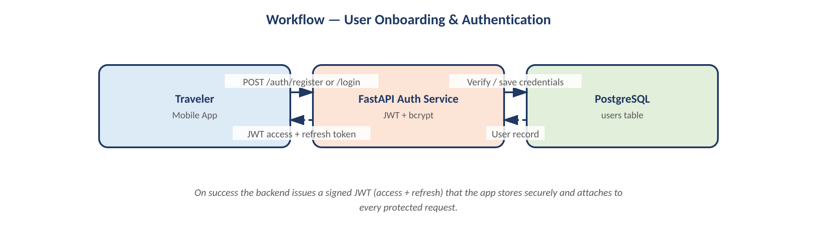
External services: none - handled internally via PostgreSQL and JWT generation. Optional Firebase configuration keys are supported for FCM push tokens.

7.2 AI Odyssey Itinerary Generation (itinerary)
Enables travelers to request custom, multi-day, budget-aligned itineraries. Generation runs asynchronously via backend background tasks so the mobile UI stays responsive.
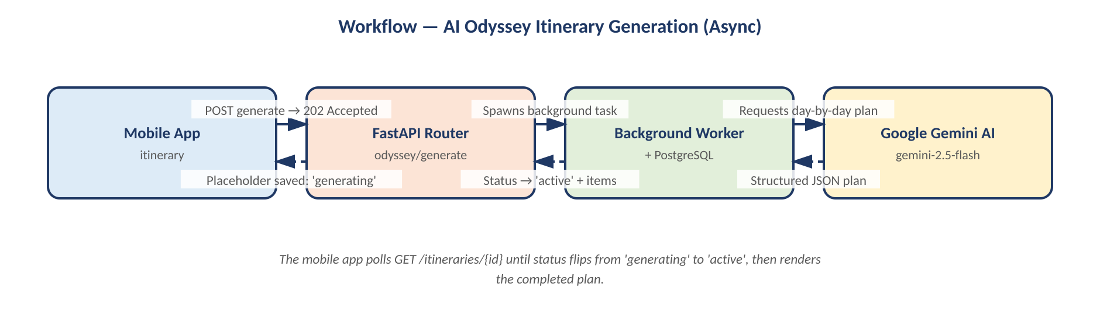
External services: Google Gemini API (gemini-2.5-flash, with gemini-1.5-pro fallback) generates the structured day-by-day itinerary JSON.

7.3 Living Map & Nearby Discovery (living_map)
Renders an interactive map centered on the user's coordinates, fetching and plotting nearby points of interest from Google Places, cached server-side via Redis to minimize third-party API costs.
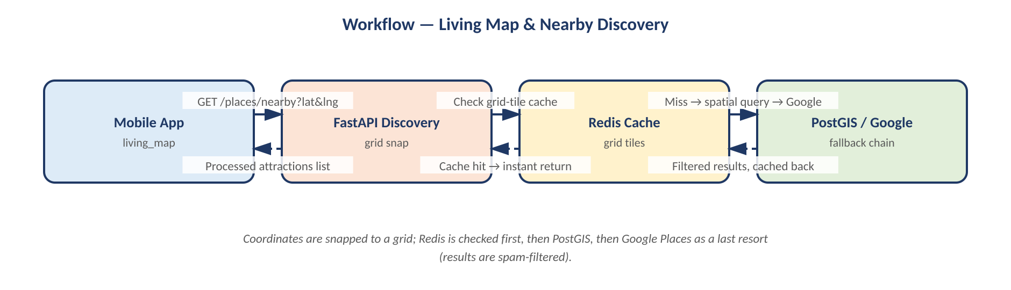
External services: Google Maps API key authorizes Places/Photos lookups; Mapbox Access Token loads vector map styling and renders coordinates client-side.

7.4 AR Mode & Live Landmark Identification (ar_mode)
Uses the device camera to capture frames, which are uploaded to the backend to identify local landmarks and return data for real-time augmented reality overlays.

External services: Google Gemini vision models (gemini-2.5-flash) perform landmark recognition; an optional Google Lens / Custom Search fallback is used when confidence is low.

7.5 AR Museum Guide & Building Masterpieces (mini_tour / museums)
Serves curated tour paths and masterpiece maps for world-class museums, including indoor floor mappings, audio guide feeds, and walking navigation paths.
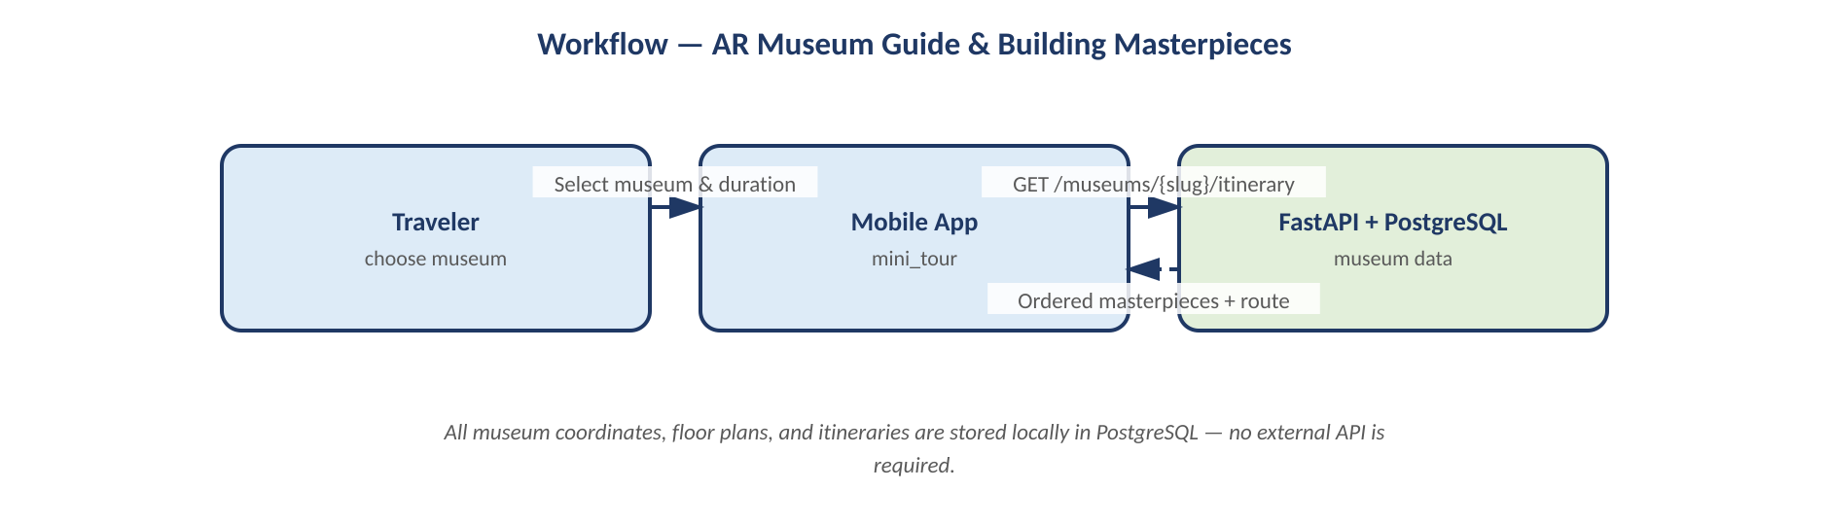
External services: none - museum coordinates, floor definitions, itineraries, and media URLs are stored locally in PostgreSQL.

7.6 Community Travel Feed & Stories (travel_stories / public)
Allows travelers to browse, search, like, and comment on public travel journals shared globally, forming a social travel network.
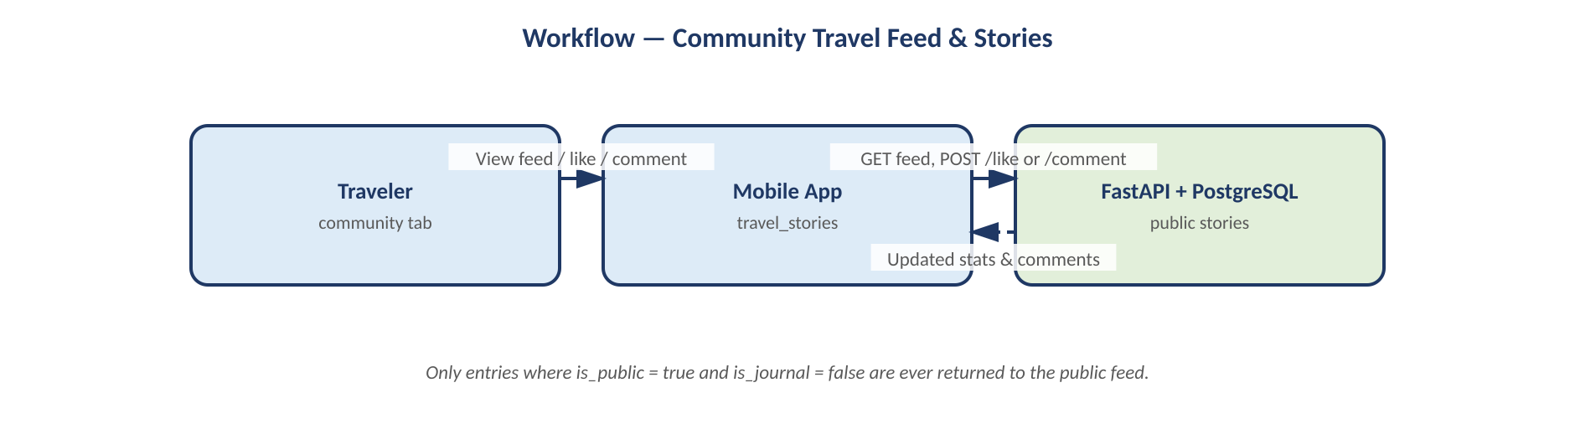
External services: none - data is stored and processed locally in PostgreSQL.

7.7 Travel Journaling & Personal Log (travel_stories / private)
A personal digital journal where travelers record check-ins, trip memories, and local coordinates. Entries can be toggled private to hide them from the public feed.
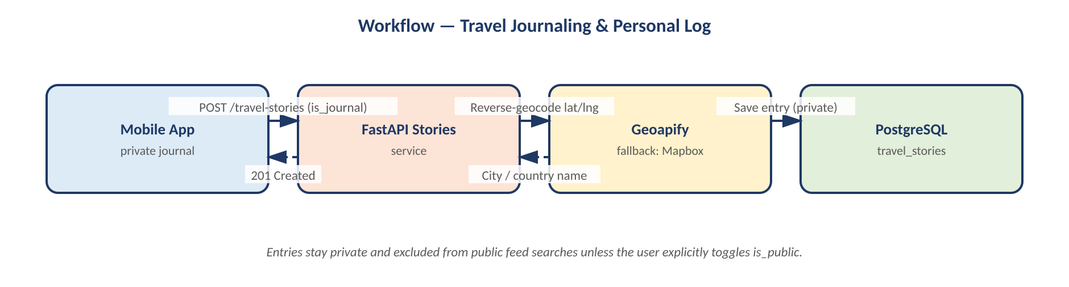
External services: Geoapify API reverse-geocodes latitude/longitude into human-readable locations; Mapbox's geocoding engine is used as a fallback if Geoapify is unavailable.

7.8 Budget Tracker & Expense Logging (budget)
Helps travelers track target budgets, log expenses across categories (Food, Transit, Lodging), and handle real-time currency conversion back to the budget's base currency.
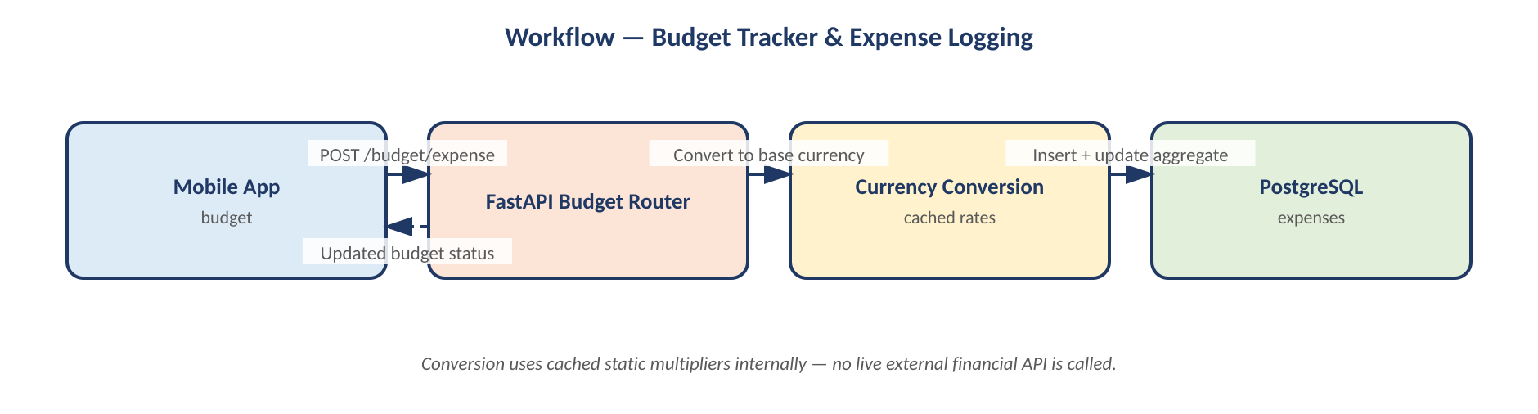
External services: none - conversion rates are resolved internally using cached static multipliers.

7.9 Neva AI Chat Companion (ai_companion)
Provides a witty, location-aware travel companion - “Neva” - capable of answering questions about history, translation, and local secrets.
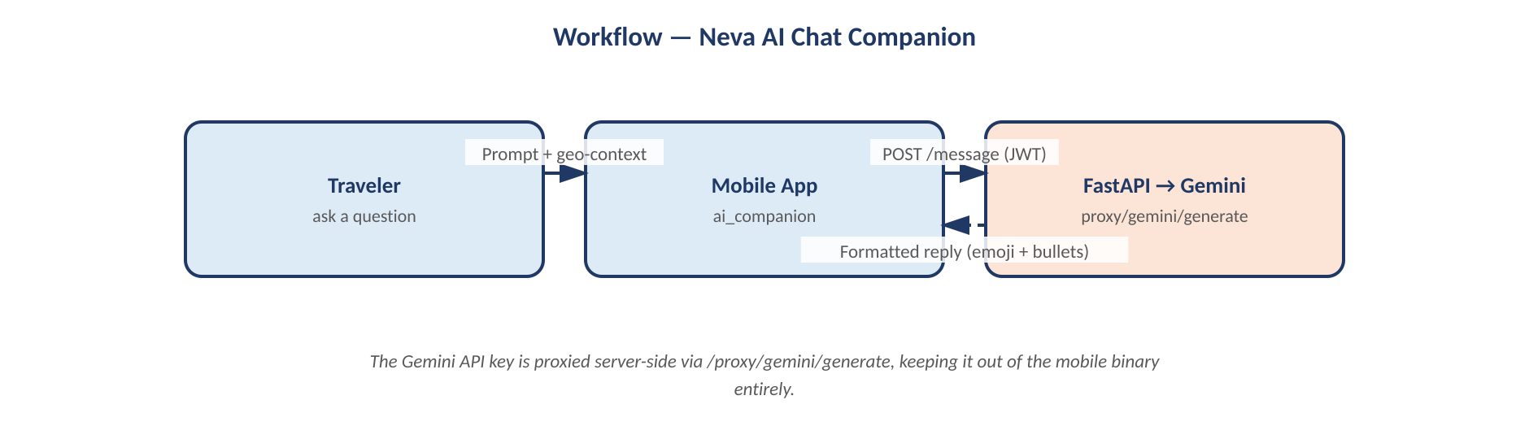
External services: Google Gemini API, proxied via /proxy/gemini/generate to keep the key off the mobile binary.

7.10 Interactive Food Radar (food_radar)
Pulls localized, context-aware trending experiences, attractions, and restaurant lists based on geographic coordinates, local weather, and popular demand.
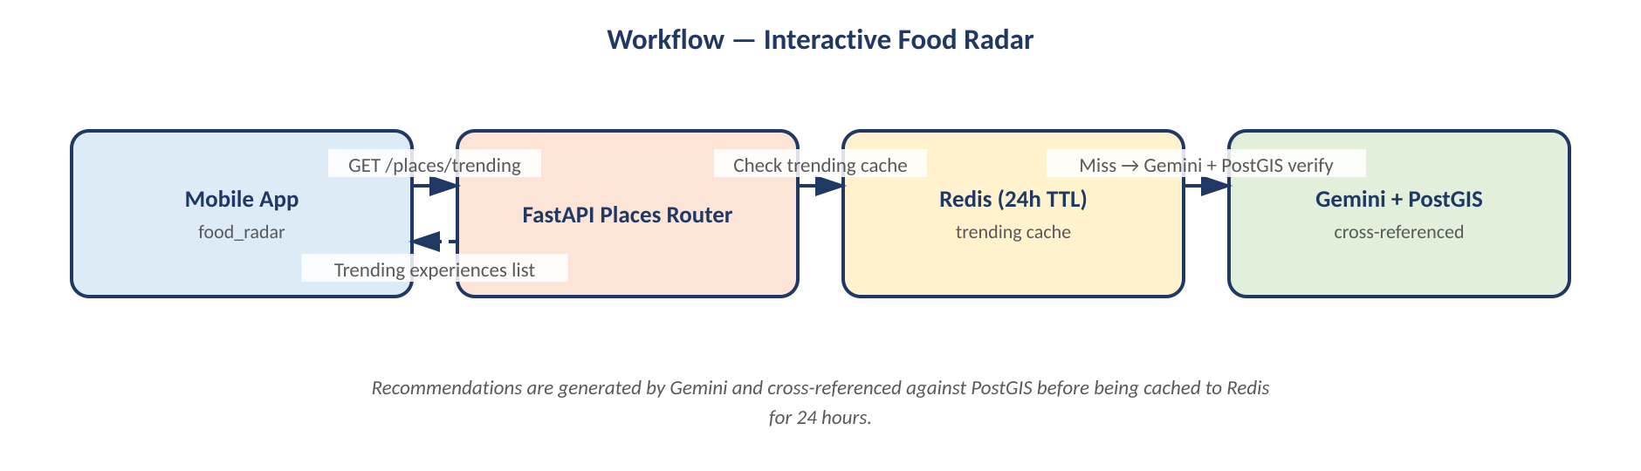
External services: Google Maps API for nearby places/reviews; Google Gemini for weather-tailored recommendation generation, cross-referenced against PostGIS.

8. Security, Compliance & System Governance
The NexAround platform implements multiple, layered security measures to protect user data, ensure secure communication, and maintain system reliability.

8.1 Transport Security
All communication between the mobile app, administrative portal, and backend is secured using HTTPS with TLS 1.2/1.3 encryption, protecting credentials and authentication tokens in transit.

8.2 Authentication and Authorization
The platform uses JSON Web Tokens (JWT) for user authentication. After login, users receive a signed JWT required for all protected endpoints. Role-Based Access Control (RBAC) ensures users, business accounts, and administrators can only perform actions permitted by their assigned role.

8.3 Input Validation and Data Protection
All incoming API requests are validated using Pydantic models before processing, helping prevent invalid data, SQL injection, cross-site scripting (XSS), and other common vulnerabilities while maintaining data integrity.

8.4 Database Security
The PostgreSQL database runs within a private Docker network and is not directly reachable from the public internet - only authorized backend services can connect to it.

8.5 API Key Protection (Secure Proxying)
The mobile app never talks to Google Maps or Gemini directly, so no third-party API key is ever embedded in the compiled binary. The mobile client instead calls the backend proxy, which attaches keys server-side before forwarding the request.

8.6 External API Key Management & Mapping Registry
To protect intellectual property and control system cost, all external API keys are secured server-side. The diagram below maps each configuration variable to its provider and the feature modules that depend on it:
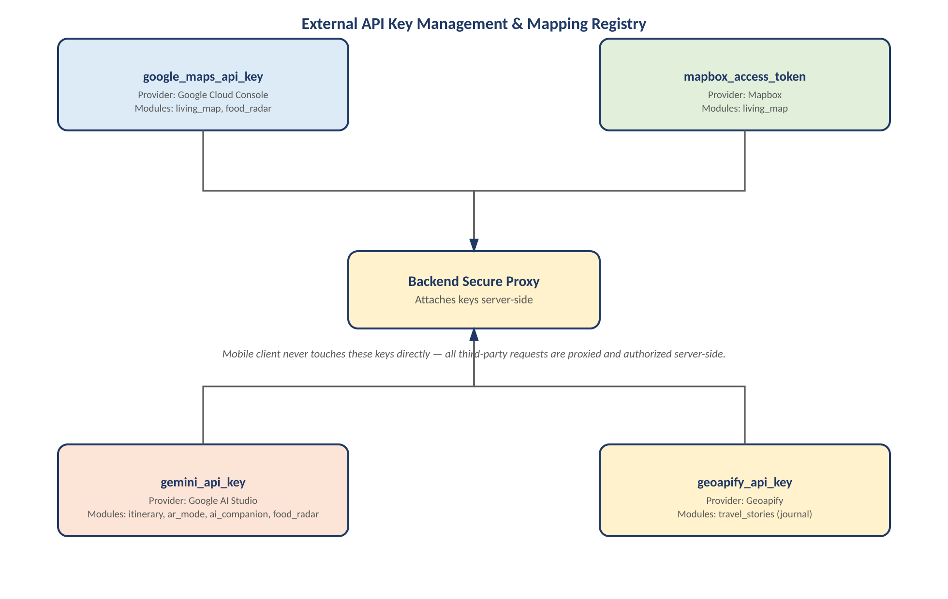
Figure 8.6 - External API keys are attached only by the backend's secure proxy, never by the mobile client.

8.7 Cost Optimization & Caching
Coordinate-Snapped Grid Cache (Redis): when querying places near a coordinate, the server snaps the coordinate onto a predefined grid and checks Redis first. Cached grid tiles serve instantly, reducing external Google Maps queries by up to 80%.
Spam & Noise Filtering: for lists such as the Nature section, the backend excludes residential listings, vacation stays, or apartments (filtering on keywords like “homestay”, “bedroom”, “apartment”, “villa”) and drops places without reviews to keep results clean.
Token Handshake: app-to-server calls are validated with JWT tokens containing encrypted user IDs, keeping endpoints safe from crawler bots and unauthorized clients.

8.8 System Governance
The platform follows a modular architecture that simplifies maintenance, monitoring, and future upgrades. Containerized deployment via Docker Compose ensures consistent environments across development and production while supporting reliable operation and scalability.

9. Infrastructure & Deployment Topology
The backend architecture is deployed on a VPS running Docker Compose behind an Nginx reverse proxy. Nginx listens on port 443 (SSL via Let's Encrypt) and routes traffic internally over the Docker bridge network to the FastAPI api container, which communicates with the db and redis containers on the private network.

9.1 Containers
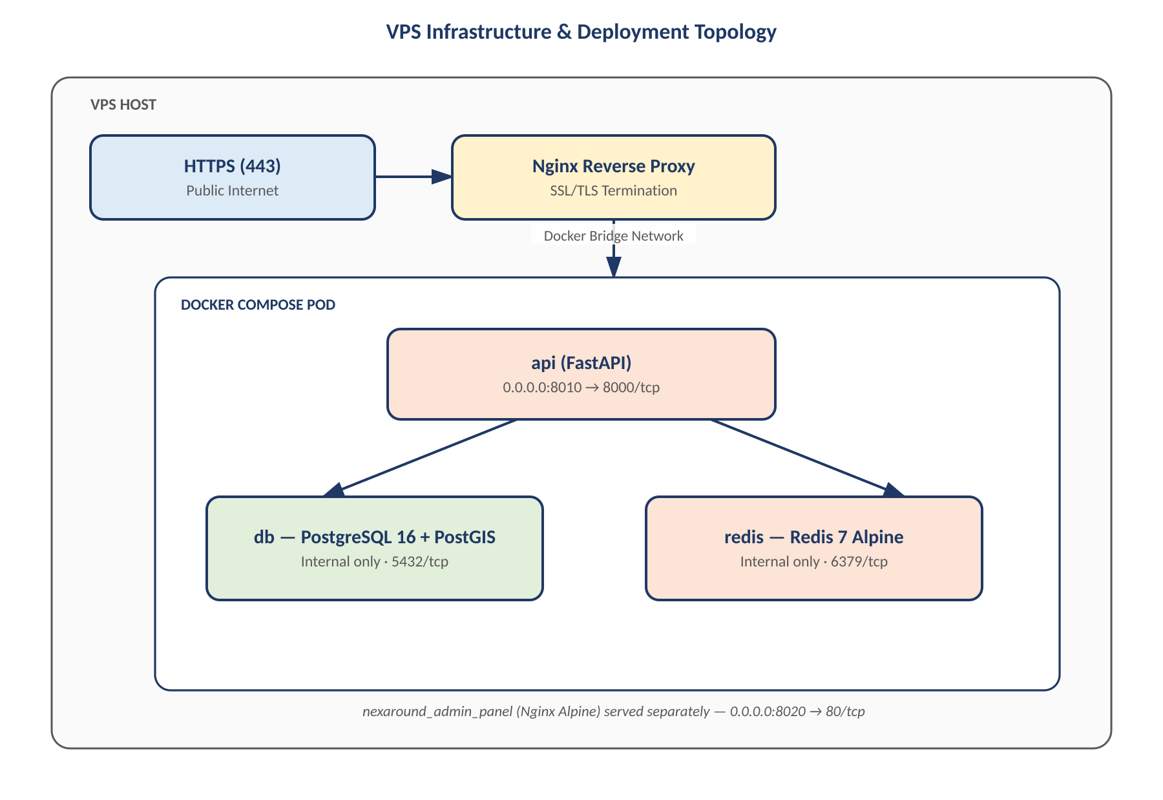
Figure 10.1 - Nginx terminates SSL at the VPS edge; only the api container is reachable from the Docker Compose pod, with db and redis kept internal.

9.2 Notes
- db and redis are bound only to the internal Docker bridge network and are not exposed publicly beyond the documented mapping.
- Container logs are formatted as raw stream files and capped at max-size: 10m to control disk usage.

10. Summary of Technical Advantages
Overall, the NexAround platform provides a scalable, secure, and modular architecture capable of supporting AI-powered travel planning, location-based services, and future feature expansion. The combination of FastAPI, PostgreSQL/PostGIS, Redis, and Docker delivers high performance while maintaining maintainability and reliability.
1. Sub-Second Spatial Performance - PostGIS spatial indexing guarantees instant location lookup even with dense attraction data.
2. High Concurrency & Responsiveness - the asynchronous FastAPI core handles thousands of concurrent requests smoothly.
3. Zero-Downtime Extensibility - the modular API architecture allows seamless addition of new features (e.g. payment gateways, new transport APIs) without impacting existing services.

